Operating System Concepts
Chapter 1 : Introduction

Based on: Silberschatz, Galvin & Gagne - 10th Edition
Shaon Khan, IIT-JU
shaon.iit52@gmail.com

Topic 01 : What is an Operating System?

Simple Explanation
An Operating System (OS) is a special program that runs on your computer all the time. It is the boss of the computer. It controls the hardware and lets other programs work on the computer.
Think of the OS as a manager at a factory. The factory workers (programs) do the work, but the manager (OS) decides who gets which machine (hardware) and when.

Real Life Example 1
Your laptop has Windows or macOS. When you open a game, the OS loads the game into memory, gives it CPU time, and connects it to your screen and speakers. You do not do all this yourself. The OS does it automatically.

Real Life Example 2
Your Android phone runs an OS called Android. Every time you touch the screen or get a notification, Android handles it behind the scenes.

Key Points
- OS is a program that sits between the user and the hardware.
- It manages CPU, memory, disk, and I/O devices.
- It helps users run applications easily.
- It is also called a resource allocator (it gives resources to programs).
- It is also a control program (it stops bad programs from breaking the system).

ASCII Diagram - Where OS Sits
+------------------------------+
| USERS / APPS | <-- You and your programs
+------------------------------+
| ^
v |
+------------------------------+
| OPERATING SYSTEM | <-- The boss (manager)
+------------------------------+
| ^
v |
+------------------------------+
| HARDWARE (CPU, RAM, Disk) | <-- Physical parts
+------------------------------+

OS Goals
Goal | Meaning
Make user life easy | Hide the complexity of hardware from users
Run user programs | Load and execute apps without crashes
Use hardware efficiently | Do not waste CPU or memory time
Keep system secure | Stop bad programs from destroying data

বাংলা সারসংক্ষেপ
অপারেটিং সিস্টেম (OS) হলো একটি বিশেষ প্রোগ্রাম যা কম্পিউটারের সব সময় চলে।
এটি ব্যবহারকারী এবং হার্ডওয়্যারের মাঝে কাজ করে।
OS, CPU, মেমোরি, ডিস্ক এবং I/O ডিভাইস নিয়ন্ত্রণ করে।
উদাহরণ: Windows, macOS, Android, Linux।

Topic 02 : Computer System Structure

Simple Explanation
A computer system has four main parts. They all work together. The OS is one of the four parts. It connects users and applications to the hardware.

The Four Parts
Part | What It Is | Example
Hardware | The physical parts of the computer | CPU, RAM, Hard Disk, Keyboard
Operating System | Controls and coordinates all hardware | Windows 11, Linux, macOS
Application Programs | Programs that users run | Word, Chrome, Games, VLC
Users | People or other programs using the computer | You, a robot, another program

ASCII Diagram - Four Parts of a Computer System
+---------------------------------------+
| USERS (People / Other Computers) |
+---------------------------------------+
|
+---------------------------------------+
| APPLICATION PROGRAMS |
| (Word, Chrome, Games ...) |
+---------------------------------------+
|
+---------------------------------------+
| OPERATING SYSTEM |
+---------------------------------------+
|
+---------------------------------------+
| HARDWARE (CPU, RAM, Disk, I/O) |
+---------------------------------------+

Real Life Example
When you use Google Chrome (Application) to watch YouTube (User action), Chrome asks the OS for network access and screen display. The OS then talks to the Network Card and GPU (Hardware) to make it happen.

Key Points
- Hardware is the physical body of the computer.
- The OS is the brain that manages everything.
- Apps are programs that users directly interact with.
- Users can be humans, machines, or other computers.

বাংলা সারসংক্ষেপ
কম্পিউটার সিস্টেমের চারটি প্রধান অংশ আছে: হার্ডওয়্যার, অপারেটিং সিস্টেম, অ্যাপ্লিকেশন প্রোগ্রাম এবং ব্যবহারকারী।
হার্ডওয়্যার হলো কম্পিউটারের শারীরিক অংশ যেমন CPU, RAM, ডিস্ক।
OS এই সব অংশের মধ্যে সমন্বয় করে।
উদাহরণ: Chrome (অ্যাপ) YouTube চালাতে OS-এর সাহায্য নেয়।

Topic 03 : Computer System Organization

Simple Explanation
Inside a computer, the CPU, memory, and all devices (like keyboard, disk, printer) are all connected by a wire called the system bus. They share this wire to send and receive data.
Each device has a small controller chip. This controller is the device's helper. It does the device's work without always bothering the CPU.

Key Terms
Term | Simple Meaning
System Bus | A shared wire connecting CPU, memory, and devices
Device Controller | A small chip that manages one type of device
Local Buffer | A small memory inside the controller for temporary data
Device Driver | Software in the OS that talks to the controller

ASCII Diagram - Computer System Organization
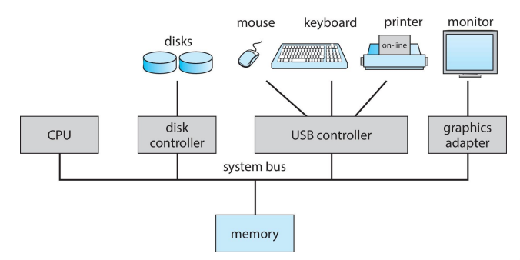

Real Life Example
When you press a key on your keyboard:
1. The key data goes to the USB Controller's local buffer.
2. The CPU reads it from the buffer into RAM.
3. The OS then gives it to the program you are typing in.
You did not do any of this. The OS and controller did it.

Key Points
- All hardware is connected through the system bus.
- Each device has its own controller and local buffer.
- The CPU copies data between main memory and local buffers.
- Device drivers in the OS control each device controller.
- I/O devices and CPU can work at the same time (concurrently).

বাংলা সারসংক্ষেপ
কম্পিউটারের ভেতরে CPU, মেমোরি এবং সব ডিভাইস সিস্টেম বাস দিয়ে যুক্ত।
প্রতিটি ডিভাইসের একটি কন্ট্রোলার এবং লোকাল বাফার আছে।
CPU মেমোরি এবং বাফারের মধ্যে ডেটা আদান-প্রদান করে।
ডিভাইস ড্রাইভার হলো OS-এর সেই অংশ যা ডিভাইস কন্ট্রোলারের সাথে কথা বলে।

Topic 04 : Interrupts

Simple Explanation
An interrupt is a signal sent to the CPU. It says: "Stop what you are doing and look at me." The CPU then pauses its current work, handles the interrupt, and goes back to what it was doing.
Interrupts let the CPU do other work while waiting for slow devices (like disks or printers). This makes the system much faster.

Common Functions of Interrupts
- Transfer control to the right handler (Interrupt Service Routine).
- Save the current CPU state (registers and program counter).
- Find which device caused the interrupt using the interrupt vector.
- Run the correct code to handle that interrupt.
- Restore the CPU state and continue the original work.

Types of Interrupts
Type | Caused By | Example
Hardware Interrupt | A physical device finishes its job | Keyboard press, Disk read done
Trap / Exception | A software error inside a program | Division by zero, bad memory access
System Call | A program asks the OS for help | Program asks OS to open a file

Interrupt Handling - Step by Step
- Device finishes its job (e.g. disk read is done).
- Device sends an interrupt signal to the CPU.
- CPU finishes its current instruction.
- CPU saves its current state (what it was doing).
- CPU looks up the interrupt vector to find the right handler.
- CPU runs the Interrupt Service Routine (ISR).
- CPU restores its old state and continues the original work.

ASCII Diagram - Interrupt Timeline
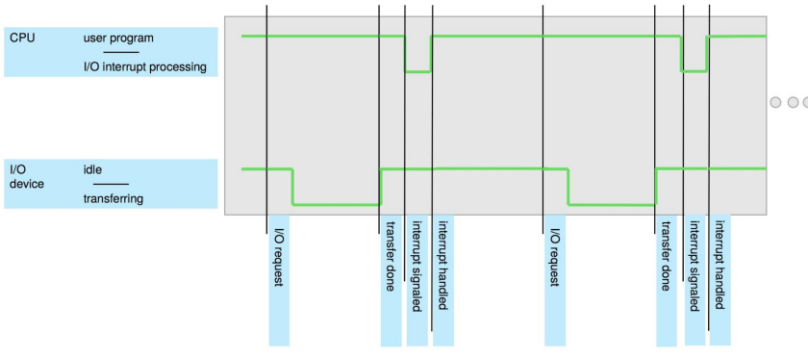

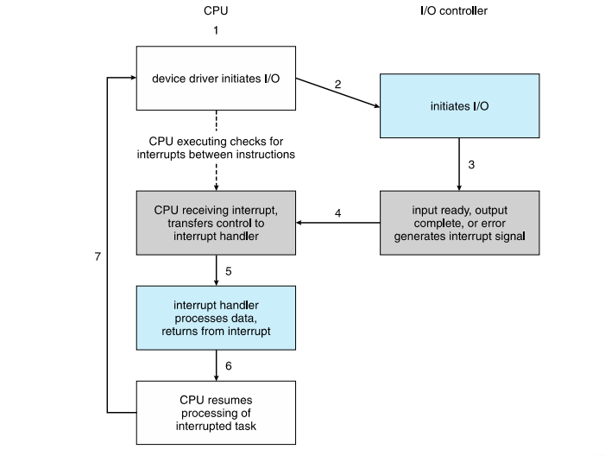

Real Life Example
You press Print in Word. The CPU sends the job to the printer and keeps working on other things (like showing your screen). When the printer finishes one page, it sends an interrupt to the CPU. The CPU quickly checks the interrupt, then goes back to its other work.

Interrupt Vector
The interrupt vector is a table stored in memory. Each entry in the table holds the address (location) of the code that handles a specific interrupt. This way, the CPU can quickly find the right handler.

বাংলা সারসংক্ষেপ
Interrupt হলো CPU-কে পাঠানো একটি সংকেত যা বলে "এখনই দেখো"।
Hardware interrupt: ডিভাইস কাজ শেষে পাঠায় (যেমন প্রিন্টার শেষ করলে)।
Trap / Exception: প্রোগ্রামের ভুলে তৈরি হয় (যেমন শূন্য দিয়ে ভাগ)।
Interrupt vector একটি টেবিল যেখানে প্রতিটি interrupt-এর handler-এর ঠিকানা থাকে।

Topic 05 : Storage Structure and Hierarchy

Simple Explanation
Computers store data in many different places. Some storage is very fast but holds a small amount. Some storage is slow but holds a lot. This is called the storage hierarchy.
The CPU can only directly use Main Memory (RAM). Everything else must be copied into RAM first before the CPU can use it.

Storage Hierarchy - Fastest to Slowest
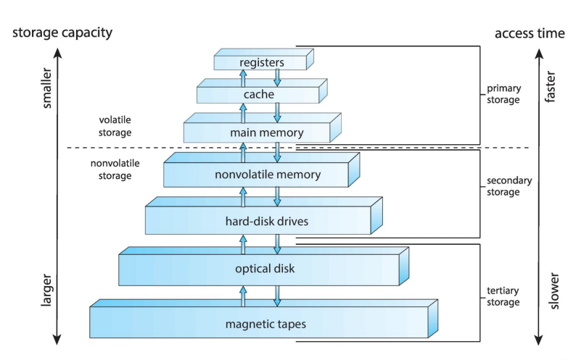

Two Important Words
Word | Meaning | Example
Volatile | Data is LOST when power is off | RAM - when you shut down, open programs are gone
Non-volatile | Data is KEPT even when power is off | Hard Disk - your files stay after shutdown

Main Memory (RAM)
- Only large storage the CPU can use directly.
- Very fast but loses all data when power is off (volatile).
- Made of DRAM chips (Dynamic Random-Access Memory).
- When you open a program, it is copied from disk to RAM.

Secondary Storage (HDD / SSD)
- HDD: Uses spinning magnetic disks. Divided into tracks and sectors.
- SSD / NVM: No moving parts. Much faster than HDD. Also non-volatile.
- Used to store your files, OS, and programs permanently.

Real Life Example 1
When you open Microsoft Word, Windows copies Word from your Hard Disk into RAM so the CPU can run it quickly. When you close Word without saving, the unsaved work in RAM is lost (volatile). Your saved file on the disk is safe (non-volatile).

Real Life Example 2
Cache memory in your CPU works like a sticky note on your desk. Instead of going to the filing cabinet (RAM) every time, the CPU keeps recently used data on the sticky note (cache) for super-fast access.

What is Caching?
Caching means copying data from a slow storage to a faster storage, so it can be accessed quickly. Example: RAM is a cache for the hard disk. Cache memory is a cache for RAM.

বাংলা সারসংক্ষেপ
কম্পিউটারে ডেটা বিভিন্ন স্তরে সংরক্ষিত হয় - এটাই স্টোরেজ হায়ারার্কি।
Volatile মেমোরি: বিদ্যুৎ চলে গেলে ডেটা মুছে যায় (যেমন RAM)।
Non-volatile মেমোরি: বিদ্যুৎ চলে গেলেও ডেটা থাকে (যেমন HDD, SSD)।
CPU শুধু সরাসরি RAM থেকে ডেটা নিতে পারে। ডিস্ক থেকে আগে RAM-এ আনতে হয়।

Topic 06 : Direct Memory Access (DMA)

Simple Explanation
Normally, the CPU moves data from a device to memory one byte at a time. This is slow. Direct Memory Access (DMA) is a way to let the device move a whole block of data directly into memory, without bothering the CPU for every byte.
The CPU only gets interrupted once at the end, when the whole block is moved. This saves a lot of CPU time.

Normal I/O vs DMA
 | Normal I/O (Without DMA) | With DMA
Who moves data? | CPU moves every byte | DMA controller moves the whole block
CPU interrupts | One interrupt per byte (very many) | One interrupt per block (just one!)
CPU time used | A lot - CPU is busy moving data | Very little - CPU is free for other work
Used for | Slow, simple devices | Fast devices like disk, network card

ASCII Diagram - DMA Process
Step 1: CPU tells DMA: "Copy 1000 bytes from Disk to RAM address 5000"

CPU DMA Controller Disk
| | |
|---Setup DMA--------->| |
| |---Read from Disk--->|
CPU does | |<----data block------|
other work | |---Write to RAM----->|
| | (direct, no CPU) |
|<---Interrupt: Done!--| |

Step 2: CPU gets ONE interrupt at the end. Block is already in RAM.

Real Life Example
When you copy a large file from USB to your computer, DMA lets the USB controller copy all the data directly into RAM. The CPU only steps in at the very start (to set up the DMA transfer) and at the very end (when the interrupt signals completion). Your CPU is free to do other things during the copy.

Key Points
- DMA is used for high-speed I/O devices.
- The DMA controller transfers blocks of data directly to/from RAM.
- Only one interrupt per block transfer, not one per byte.
- Frees the CPU for other useful work during data transfer.
- Common in disk drives, network cards, sound cards, and USB.

বাংলা সারসংক্ষেপ
DMA (Direct Memory Access) হলো একটি পদ্ধতি যেখানে ডিভাইস সরাসরি মেমোরিতে ডেটা পাঠাতে পারে।
এতে CPU-কে প্রতিটি byte-এর জন্য কাজ করতে হয় না।
পুরো block transfer শেষে মাত্র একটি interrupt পাঠানো হয়।
ফলে CPU অন্য কাজ করতে পারে এবং সিস্টেম দ্রুত হয়।

Topic 07 : Operating System Operations

Simple Explanation
When you turn on a computer, several things happen in a specific order before you can use it. Understanding this process helps you understand how the OS starts and keeps control of the computer.

Step 1 - Bootstrap Program
The Bootstrap program (also called the bootloader) is the very first program that runs when you turn on the computer. It is stored in ROM (a chip on the motherboard, not the hard disk).
- It wakes up the CPU and checks the hardware.
- It finds the OS kernel on the disk.
- It loads the OS kernel into RAM.
- It hands control to the OS kernel.

Step 2 - The Kernel
The Kernel is the core of the OS. It is the most important part. It runs all the time while the computer is on. All other programs depend on the kernel.
- Manages CPU, memory, and devices.
- Runs in a special protected mode (kernel mode).
- Starts system daemons (background services like Wi-Fi manager, clock sync).

Step 3 - System Daemons
Daemons are background programs that start when the OS boots. They run quietly and provide services. Examples: Network manager, Print spooler, Antivirus scanner.

ASCII Diagram - Boot Process
Power On
|
v
Bootstrap (ROM) --> Check hardware --> Find OS on Disk
|
v
Load Kernel into RAM
|
v
Kernel Starts --> Start Daemons --> Show Login Screen
|
v
OS is Running (waiting for user input)

Types of Software Interrupts (Trap and Exception)
Type | What Causes It | Example
System Call (Trap) | A program asks the OS for a service | App asks OS to read a file
Exception (Error) | A program makes a mistake | Dividing a number by zero
Hardware Interrupt | A device signals the CPU | Keyboard key pressed

Real Life Example - Bootstrap
When you press the power button on your Dell laptop, the BIOS (bootstrap) stored on a ROM chip starts. It checks your RAM sticks and keyboard. Then it reads Windows from your SSD and loads it into RAM. Then Windows (kernel) takes over.

Real Life Example - System Call
When an app like WhatsApp wants to access your microphone, it does not touch the microphone directly. It makes a system call to the OS: "Please give me microphone access." The OS checks permission, then grants or denies it.

বাংলা সারসংক্ষেপ
Bootstrap প্রোগ্রাম কম্পিউটার চালু হলে প্রথমে চলে এবং OS কার্নেলকে RAM-এ লোড করে।
কার্নেল হলো OS-এর মূল অংশ যা সব সময় চলে এবং সব কিছু নিয়ন্ত্রণ করে।
Trap হলো সফটওয়্যার-জনিত interrupt - হয় প্রোগ্রামের ভুলে বা OS-এর সাহায্য চাইতে।
System Call হলো একটি প্রোগ্রামের OS-এর কাছে সাহায্য চাওয়ার উপায়।

Topic 08 : Multiprogramming vs Multitasking

The Problem
A single program often has to wait. For example, it waits for a disk to load a file or for the printer to finish. During this waiting time, the CPU has nothing to do. This wastes CPU time.

Solution 1 - Multiprogramming
Multiprogramming keeps multiple programs in memory at the same time. When one program waits, the CPU quickly switches to another program. The CPU stays busy all the time.
- Multiple jobs are loaded into memory together.
- The OS picks one job to run at a time (Job Scheduling).
- When the running job waits for I/O, the OS switches to another job.
- Goal: Keep the CPU busy 100% of the time.

Solution 2 - Multitasking (Time-Sharing)
Multitasking is an extension of multiprogramming. The CPU switches between programs so fast (many times per second) that each user feels they have the CPU all to themselves. This is called interactive computing.
- Response time should be less than 1 second so users feel it is instant.
- Each user has at least one process running.
- CPU Scheduling decides who gets the CPU next.
- If too many programs are in memory: Swapping (move some out to disk).
- Virtual Memory allows programs bigger than RAM to run.

Comparison Table - Multiprogramming vs Multitasking
Feature | Multiprogramming | Multitasking (Time-Sharing)
Main Goal | Keep CPU busy | Give each user fast response
Switching Speed | Switches only when a job waits | Switches every few milliseconds
User Interaction | No - batch jobs, no user input | Yes - user types and sees results
Response Time | Not important | Must be very short (< 1 sec)
Example System | Old mainframe batch system | Windows, Linux, macOS on your PC

Real Life Example - Multitasking
On your Windows PC, you can have Spotify playing music, Chrome downloading a file, and Word open at the same time. The CPU switches between these tasks thousands of times per second. You do not notice the switching. It feels like everything runs together.

Real Life Example - Multiprogramming
In a bank's old mainframe, 100 reports are submitted at night. The OS loads them all and runs them one by one. While one report waits for a file, the CPU processes the next report. No human interaction needed.

Key Terms
Term | Meaning
Process | A program that is currently running in memory
Job Scheduling | The OS picks which job gets the CPU next
Swapping | Moving a process from RAM to disk to free up space
Virtual Memory | Using disk space as if it were extra RAM

বাংলা সারসংক্ষেপ
Multiprogramming: একসাথে অনেক প্রোগ্রাম মেমোরিতে রাখা হয়; CPU সবসময় ব্যস্ত থাকে।
Multitasking: CPU এত দ্রুত প্রোগ্রাম বদলায় যে ব্যবহারকারী মনে করে সব একসাথে চলছে।
Swapping: RAM ভরে গেলে কিছু প্রোগ্রাম ডিস্কে পাঠানো হয়।
Virtual Memory: ডিস্ককে অতিরিক্ত RAM হিসেবে ব্যবহার করা।

Topic 09 : Dual-Mode Operation

Simple Explanation
The OS must protect itself from bad or buggy programs. If any program could do anything it wanted (like directly touching hardware), one bad program could crash the whole system.
To prevent this, CPUs have two modes: User Mode and Kernel Mode. The CPU hardware switches between these modes using a special bit called the mode bit.

The Two Modes
Feature | User Mode | Kernel Mode
Who runs here? | All user applications (apps, games, browsers) | Only the OS kernel
Hardware access? | NO - cannot directly touch hardware | YES - full access to all hardware
Mode bit value | 1 (user mode) | 0 (kernel mode)
Privileged instructions? | Cannot run privileged instructions | Can run all privileged instructions
Example | Your Chrome browser | OS handling a disk read request

ASCII Diagram - Mode Switching
User Mode (mode bit = 1)
+--------------------------+
| User Program Running ... |---[Makes System Call]---+
+--------------------------+ |
v
Kernel Mode (mode bit = 0)
+--------------------------+
| OS handles the request |---[Returns result]------+
| (e.g. reads a file) | |
+--------------------------+ |
v
User Mode (mode bit = 1)
+--------------------------+
| User Program continues |
+--------------------------+

What are Privileged Instructions?
Some CPU instructions are very powerful. They can directly control hardware or change memory protection. These are called privileged instructions. They can ONLY run in Kernel Mode.
- Accessing I/O devices directly.
- Modifying the mode bit (only the kernel can do this).
- Changing memory management settings.
- Stopping or resuming other programs.

Real Life Example
When your photo editor app wants to save a file to disk, it cannot write to the disk directly (user mode has no permission). It makes a system call: "OS, please write this data to my file." The OS switches to kernel mode, writes to disk, then returns control to the app in user mode. This keeps the disk safe from rogue programs.

How System Boot Relates to Modes
When the computer first starts, the hardware is in kernel mode. The OS loads and runs. When the OS starts your apps, it switches to user mode. Every time an app needs OS help, it switches back to kernel mode briefly.

বাংলা সারসংক্ষেপ
CPU দুটি মোডে কাজ করে: User Mode এবং Kernel Mode।
User Mode-এ সাধারণ অ্যাপ চলে; সরাসরি হার্ডওয়্যার ব্যবহার করতে পারে না।
Kernel Mode-এ শুধু OS চলে; সব হার্ডওয়্যার ব্যবহার করতে পারে।
System Call করলে User Mode থেকে Kernel Mode-এ যাওয়া হয় এবং কাজ শেষে ফিরে আসে।

Topic 10 : Timer

Simple Explanation
What happens if a program accidentally goes into an infinite loop and never stops? The CPU would be stuck on that one program forever. Other programs and the OS would never get a turn.
To prevent this, the OS uses a hardware Timer. The timer counts down from a set number. When it reaches zero, it sends an interrupt to the CPU. The OS then takes back control.

How the Timer Works - Step by Step
- The OS sets the timer value before starting a program (a privileged instruction).
- The timer counts down with every tick of the hardware clock.
- The program runs normally.
- If the program runs too long, the timer reaches zero.
- Timer sends an interrupt to the CPU.
- OS takes control. It can stop, pause, or continue the program.

ASCII Diagram - Timer
OS sets timer = 100ms
|
Program starts running
|
Timer counts: 100 ... 50 ... 10 ... 0
|
INTERRUPT! OS takes control
|
OS decides: let it run more? OR switch to another program?

Real Life Example 1
On your Windows PC, if a program freezes (like an infinite loop), Windows detects it after a few seconds using its timer system. Windows shows you "Not Responding" and gives you the option to close it. Without the timer, Windows would be frozen forever too.

Real Life Example 2
In multitasking, the OS gives each program a time slice (like 10 milliseconds). The timer is set to 10ms. When it fires, the OS switches to the next program. This is how your PC runs many programs at the same time fairly.

Key Points
- Timer prevents any single program from hogging the CPU forever.
- Setting the timer is a privileged instruction - only OS can do it.
- Users cannot disable or change the timer value.
- Timer interrupts are the heartbeat of multitasking systems.
- Used to implement time slices in CPU scheduling.

বাংলা সারসংক্ষেপ
Timer হলো একটি হার্ডওয়্যার ঘড়ি যা OS সেট করে।
যদি কোনো প্রোগ্রাম বেশি সময় CPU দখল করে রাখে, Timer শেষ হলে interrupt পাঠায়।
OS তখন নিয়ন্ত্রণ নেয় এবং সিদ্ধান্ত নেয় কী করবে।
Timer সেট করা একটি privileged instruction - শুধু OS করতে পারে।

Topic 11 : Virtualization and Virtual Machines

Simple Explanation
Virtualization is a way to make one physical computer act like many computers. Each "fake computer" is called a Virtual Machine (VM). Each VM has its own OS and behaves like a real separate computer.
Virtualization is done by special software called a VMM (Virtual Machine Monitor) or Hypervisor. The VMM sits between the physical hardware and the virtual machines.

Types of Hypervisors
Type | How It Works | Example
Type 1 (Bare-Metal) | Runs directly on hardware. No host OS needed. | VMware ESXi, Microsoft Hyper-V
Type 2 (Hosted) | Runs inside a host OS like a normal program. | VirtualBox, VMware Workstation

Key Points
- One physical computer can run many VMs at the same time.
- Each VM is completely isolated - a crash in one VM does not affect others.
- VMs are used in cloud computing (Amazon AWS, Google Cloud).
- VMs can be saved, copied, and moved easily (like a file).
- Used for testing, running multiple OS types, and server efficiency.

Real Life Example 1
A company has one powerful physical server. Using VMware, they create 10 VMs on it. Five VMs run Windows Server for their business apps, three run Linux for their website, and two run for testing. One physical machine does the work of ten.

Real Life Example 2
You use VirtualBox on your Windows laptop to run Ubuntu Linux inside a window. The Ubuntu is a VM. You can take a snapshot (save the state), delete it, or copy it to another computer easily.

বাংলা সারসংক্ষেপ
Virtualization হলো একটি ফিজিক্যাল কম্পিউটারকে অনেকগুলো ভার্চুয়াল কম্পিউটারের মতো চালানো।
প্রতিটি Virtual Machine (VM)-এর নিজস্ব OS এবং অ্যাপ থাকে।
VMM বা Hypervisor এই ভার্চুয়াল মেশিন তৈরি ও পরিচালনা করে।
Cloud computing-এ এটি ব্যাপকভাবে ব্যবহার হয়। উদাহরণ: Amazon AWS, VirtualBox।

Topic 12 : Cloud Computing

Simple Explanation
Cloud computing means using computers, storage, and software over the Internet. Instead of buying and maintaining your own servers, you rent computing power from a cloud provider (like Amazon or Google). You pay only for what you use.
Cloud computing is built on top of virtualization. The cloud provider creates millions of VMs and rents them out to customers.

Types of Cloud
Type | Who Can Use It? | Example
Public Cloud | Anyone who pays over the Internet | Amazon AWS, Google Cloud, Microsoft Azure
Private Cloud | Only one company - runs inside the company | A bank running its own cloud for security
Hybrid Cloud | Mix of public and private | Company keeps private data in-house, uses public cloud for apps

Three Service Models - SaaS, PaaS, IaaS
+---------------------------------------------------+
| SaaS - Software as a Service |
| You use the software. No setup needed. |
| Example: Gmail, Google Docs, Dropbox, Zoom |
+---------------------------------------------------+
| PaaS - Platform as a Service |
| You deploy your app. Cloud provides the platform.|
| Example: Google App Engine, Heroku, Azure SQL |
+---------------------------------------------------+
| IaaS - Infrastructure as a Service |
| You get virtual machines and storage. |
| Example: Amazon EC2, Google Compute Engine |
+---------------------------------------------------+
^ ^ ^
Most managed Medium control Full control
by provider shared by you

Cloud Architecture - ASCII
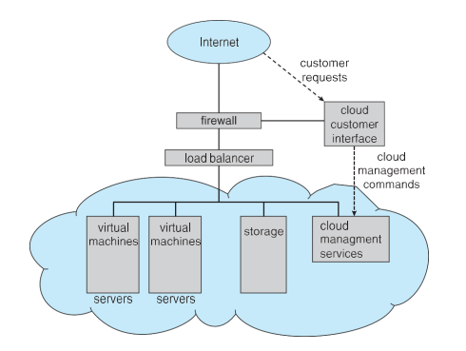

Real Life Example - SaaS
You use Google Docs to write an essay. You do not install anything. Google runs the software on their servers. You access it through your browser. Google handles all the hardware, OS, and maintenance. This is SaaS.

Real Life Example - IaaS
A startup company needs 10 servers for their app launch. Instead of buying physical servers (very expensive and slow), they rent 10 VMs on Amazon EC2 in 5 minutes. When user traffic drops, they scale down to 2 VMs to save money. This is IaaS.

Key Points
- Cloud = computing resources (CPU, storage, software) delivered over the Internet.
- Built on virtualization - thousands of VMs on giant data centers.
- SaaS: use the software (Gmail, Office 365).
- PaaS: build and deploy your app (Heroku, Azure).
- IaaS: rent raw virtual hardware (Amazon EC2, Google Compute).
- Public cloud is for everyone. Private is for one company. Hybrid is both.

বাংলা সারসংক্ষেপ
Cloud Computing মানে ইন্টারনেটের মাধ্যমে কম্পিউটার, স্টোরেজ এবং সফটওয়্যার ব্যবহার করা।
SaaS: সফটওয়্যার ব্যবহার করো (Gmail, Zoom)। PaaS: অ্যাপ তৈরি করো (Heroku)। IaaS: হার্ডওয়্যার ভাড়া নাও (Amazon EC2)।
Public Cloud সবার জন্য, Private Cloud একটি কোম্পানির জন্য, Hybrid দুটোর মিশ্রণ।
Cloud, Virtualization-এর উপর ভিত্তি করে তৈরি।

Topic 13 : Real-Time Embedded Systems

Simple Explanation
A Real-Time OS (RTOS) is designed for systems where tasks MUST finish within a strict time limit. Missing the deadline can cause serious problems or even death. These systems are used in machines and devices, not on regular desktop computers.
Embedded systems are computers built into other machines (like cars, medical devices, washing machines). They usually run a limited, special-purpose OS.

Hard Real-Time vs Soft Real-Time
Feature | Hard Real-Time | Soft Real-Time
Deadline | MUST be met - no exceptions ever | Can miss deadline occasionally
What happens if deadline missed? | Catastrophic failure, danger, or death | Reduced quality, user annoyance
Virtual memory allowed? | No - too unpredictable | Yes
Storage | ROM or Flash - no hard disks | Any storage
Examples | Pacemaker, aircraft control, nuclear plant | Video streaming, video games, navigation app
Complexity | Very strict, minimal OS | More flexible OS

Real Life Example - Hard Real-Time
A pacemaker is implanted in a heart patient. It must send an electrical pulse every 800 milliseconds exactly. If it is even 100ms late, the patient's heart can stop. This is a hard real-time system. The timing cannot be wrong even once.

Real Life Example - Soft Real-Time
When you watch Netflix, the video player must show 30 frames per second. If a frame or two is late (the video briefly stutters), it is annoying but not dangerous. Netflix uses a soft real-time approach for video delivery.

Examples of Real-Time Embedded Systems
- Aircraft flight control systems (hard real-time)
- Anti-lock braking system (ABS) in cars (hard real-time)
- Insulin pump / pacemaker in medicine (hard real-time)
- Video game consoles (soft real-time)
- Robot arm in a car factory (hard real-time)
- Washing machine controller (embedded, basic real-time)

বাংলা সারসংক্ষেপ
Real-Time OS এমন সিস্টেমে ব্যবহার হয় যেখানে কাজ নির্দিষ্ট সময়ের মধ্যে শেষ করতেই হবে।
Hard Real-Time: সময় মিস করলে বিপর্যয় - যেমন পেসমেকার, বিমান নিয়ন্ত্রণ।
Soft Real-Time: সময় একটু মিস হলে মানা যায় - যেমন ভিডিও স্ট্রিমিং, গেমস।
Embedded system হলো অন্য মেশিনের ভেতরে বসানো কম্পিউটার, যেমন গাড়ি বা মেডিকেল ডিভাইস।

Topic 14 : Distributed Operating System

Simple Explanation
A Distributed OS connects many separate computers through a network. These computers work together as if they are one big computer. The user does not know (or care) which physical machine is actually doing their work.

Key Characteristics
- Multiple computers connected by a network (LAN or Internet).
- Users share resources - files, printers, processors.
- If one computer fails, others continue working (fault tolerance).
- Jobs are split across computers for speed (load balancing).
- Looks like a single system to the user (transparency).

Advantages of Distributed OS
Advantage | What It Means
Resource Sharing | One computer can use another computer's printer, file, or CPU
Speedup | A big job can be split across many computers and done faster
Reliability | If one machine fails, others keep working (no single point of failure)
Scalability | Add more computers to the network easily to handle more work

Real Life Example 1
Google Search uses thousands of computers in many countries. When you search "weather today," your query is sent to the nearest data center. Multiple computers search different parts of Google's index in parallel. Your results arrive in under 1 second. This is a distributed system.

Real Life Example 2
A university has 50 computer lab machines. A distributed OS lets them share files and printers. A student can log in at any machine and see their files (stored on a central server). They submit a big simulation job and it runs across 10 machines at once for speed.

বাংলা সারসংক্ষেপ
Distributed OS অনেকগুলো আলাদা কম্পিউটারকে নেটওয়ার্কের মাধ্যমে একত্রিত করে।
ব্যবহারকারী মনে করে একটি সিস্টেম ব্যবহার করছে, কিন্তু আসলে অনেক মেশিন কাজ করছে।
একটি মেশিন নষ্ট হলে বাকিগুলো কাজ করতে পারে (fault tolerance)।
উদাহরণ: Google Search, বিশ্ববিদ্যালয়ের শেয়ারড কম্পিউটার ল্যাব।

Topic 15 : Network Operating System

Simple Explanation
A Network OS (NOS) runs on a central server. It manages shared resources (like files and printers) on a Local Area Network (LAN). Unlike a Distributed OS, each machine is still aware it is separate. Users log into the server to access shared resources.

Distributed OS vs Network OS - Comparison
Feature | Network OS (NOS) | Distributed OS
Machine awareness | Each computer knows it is separate | Computers appear as one single system
User experience | User explicitly connects to the server | User sees one unified system - transparent
Resource access | User knows which server has the file | User does not know where file is stored
Failure handling | If server fails, clients are cut off | Other nodes continue working
Examples | Windows Server, Novell NetWare, Linux Server | Google, Amazon AWS, Hadoop cluster

Real Life Example
In your school or office, there is a Windows Server. You log in with your username and password. You can access shared folders (like H: drive), print to the shared printer, and access shared software. Each student knows they are connecting to the server - it is not transparent. This is a Network OS at work.

Key Points
- NOS runs on a server that manages shared resources.
- Clients explicitly connect to the server to use shared resources.
- Provides file sharing, printer sharing, and user authentication.
- Examples: Windows Server 2019, Ubuntu Server, Novell NetWare.
- Common in schools, offices, and small company networks.

বাংলা সারসংক্ষেপ
Network OS একটি সার্ভারে চলে এবং নেটওয়ার্কের অন্য কম্পিউটারগুলোকে ফাইল ও প্রিন্টার শেয়ার করতে দেয়।
প্রতিটি কম্পিউটার জানে সে আলাদা এবং সে সার্ভারের সাথে সংযুক্ত হচ্ছে।
Distributed OS-এ ব্যবহারকারী জানে না কোন মেশিন কাজ করছে; NOS-এ জানে।
উদাহরণ: স্কুল বা অফিসের Windows Server যেখানে সবাই login করে ফাইল শেয়ার করে।

Topic 16 : Open-Source Operating Systems

Simple Explanation
Open-source software means the source code (the original programming instructions) is freely available to everyone. Anyone can read it, change it, and share it. This is the opposite of closed-source software where only the company can see the code.

Open-Source vs Closed-Source
Feature | Open-Source OS | Closed-Source OS
Source code | Freely available to everyone | Secret - only the company sees it
Cost | Usually free | Usually paid (Windows license costs money)
Who can modify? | Anyone | Only the company's developers
Trust / Audit | Anyone can check for bugs or backdoors | You must trust the company
Examples | Linux, Android, BSD, Firefox OS | Windows, macOS, iOS

Key Organizations and Licenses
Name | What It Is
FSF (Free Software Foundation) | Organization that promotes free/open software. Founded by Richard Stallman in 1985.
GNU Project | A project to create a completely free UNIX-like OS. Provides tools like GCC compiler, Bash shell.
GPL (GNU Public License) | A legal license. If you modify GPL code, you MUST share your changes as open source too. Called "copyleft."
Linux Kernel | The kernel created by Linus Torvalds in 1991. Combined with GNU tools = GNU/Linux.
BSD (Berkeley Software Distribution) | A family of UNIX-based open-source OSes. macOS is based on BSD. Less strict license than GPL.

Famous Open-Source Operating Systems
- GNU/Linux: Used on servers (70%+ of web servers), Android phones, supercomputers, smart TVs.
- Android: Based on Linux kernel. Used on 3 billion+ phones worldwide.
- FreeBSD: Used inside PlayStation 4 and 5 OS, Netflix servers, WhatsApp servers.
- OpenBSD: Famous for security. Used in firewalls.
- Ubuntu / Fedora / Debian: Popular Linux distributions for desktops and servers.

Real Life Example 1
Your Android phone runs on a Linux kernel. Every app you open uses the Linux OS underneath. Android is the largest open-source OS in the world by number of users. The source code is available at source.android.com.

Real Life Example 2
Wikipedia runs its entire website on Linux servers (open source). Facebook, Google, Amazon - all use Linux for their data centers. The reason: it is free, reliable, and anyone can customise it for their needs.

Key Points
- Open-source OS: source code is public and free to modify.
- GPL license: any modification must also be shared openly.
- BSD license: more permissive - Apple used it for macOS without sharing changes.
- Linux + GNU tools = a complete open-source OS.
- Open source enables community testing, faster bug fixes, and trust.

বাংলা সারসংক্ষেপ
Open-source OS মানে যার সোর্স কোড সবার জন্য উন্মুক্ত - যে কেউ পড়তে, পরিবর্তন করতে এবং শেয়ার করতে পারে।
GPL লাইসেন্স: কোড পরিবর্তন করলে সেটাও open-source রাখতে হবে।
GNU/Linux: GNU tools + Linux Kernel = সম্পূর্ণ বিনামূল্যের OS।
উদাহরণ: Android (Linux-ভিত্তিক), Ubuntu, FreeBSD (PlayStation-এ ব্যবহৃত)।

Quick Revision Summary - All 16 Topics

# | Topic | One Line Summary
01 | What is an OS? | Software that manages hardware and lets programs run easily.
02 | Computer System Structure | 4 parts: Hardware, OS, Applications, Users.
03 | Computer System Organization | CPU + Memory + Devices connected by system bus. Each device has a controller.
04 | Interrupts | Signal to CPU: "I am done, look at me." Types: Hardware, Trap, System Call.
05 | Storage Hierarchy | Registers > Cache > RAM > SSD > HDD > Tape. Fast to slow, small to large.
06 | Direct Memory Access (DMA) | Device copies block of data to RAM directly. CPU only interrupted once.
07 | OS Operations | Bootstrap loads kernel. Kernel runs all the time. Traps = software interrupts.
08 | Multiprogramming vs Multitasking | Multiprogramming: keep CPU busy. Multitasking: fast switching for interactive use.
09 | Dual-Mode Operation | User Mode (apps, no hardware access) + Kernel Mode (OS, full access). Mode bit switches between them.
10 | Timer | Prevents infinite loops. OS sets timer; it fires an interrupt when time is up.
11 | Virtualization | One physical computer runs many Virtual Machines. VMM manages them.
12 | Cloud Computing | Computing over the Internet. SaaS (use app), PaaS (build app), IaaS (rent hardware).
13 | Real-Time Embedded Systems | Hard: deadline must be met (pacemaker). Soft: can miss sometimes (video stream).
14 | Distributed OS | Many computers work as one. Transparent to user. Fault tolerant.
15 | Network OS | Server manages shared files/printers for clients. Users know they connect to server.
16 | Open-Source OS | Source code is public. GNU/Linux, BSD. GPL license requires sharing changes.

End of Chapter 1 - Introduction to Operating Systems
Based on: Silberschatz, Galvin & Gagne - Operating System Concepts, 10th Edition
Shaon Khan
IIT-14, JU-52
01633040670

